30.57: Multiplying Eq. (30.27) by i, yields:
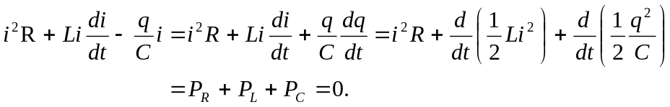
That is, the rate of energy dissipation throughout the circuit must balance over all of the circuit elements.

